**Building and Breaking Molecular Ladders**

**to Develop Antiaromatic and Force-Responsive Materials**

Yan Xia

Department of Chemistry, Stanford University

Our interest in utilizing and incorporating strained rings in ladder-shaped molecular structures led to the development of unusual functional materials. We developed Catalytic Arene-Norbornene AnnuLation (CANAL) to synthesize π-systems containing antiaromatic cyclobutadienoid from readily accessible oxanorbornenes and aryl bromides.[1] These extended conjugated ladder molecules exhibit tunable degrees of antiaromaticity, which in turn affect their bonding, frontier orbital levels, and optoelectronic properties. In the quest for synthetic materials that transduce mechanical stimulation to multifaceted signals in response to force, we developed a unique class of polyladderenes, which rapidly unzip under force into polyacetylene with long conjugation.[2] The force-induced breaking of macromolecular ladders opens new avenues for smart materials that transform their intrinsic properties drastically under force and understanding details of mechanotransduction in polymers.

[1] J. Am. Chem. Soc. **2017**, *139*, 1806; **2017**, *139*, 15933.

[2] Science **2017**, 357, 475.

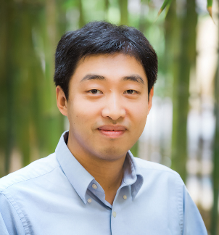

Yan Xia received his undergraduate degree from Peking University ('02) and MSc from McMaster University ('05). He then obtained his PhD in Chemistry from Caltech in 2010, working on cyclic and bottlebrush polymers under the guidance of Profs. Robert Grubbs and Julie Kornfield. Following his PhD, he worked as a senior chemist at Dow Chemical for one and a half years and then a postdoc associate at MIT. He joined the chemistry faculty at Stanford in the summer of 2013. His research interest lies in the design, synthesis, and manipulation of organic materials and polymers, driven by new synthetic capability, rational molecular design, and curiosity. He is a recipient of Terman Fellowship (2014), ARO Young Investigator Award (2015), 3M Non-Tenured Faculty Award (2016), NSF CAREER Award (2016), Thieme Chemistry Journals Award (2017), and Cottrell Scholar Award (2017).