**学术报告**

**题目：The Formation of Damaged DNA is Only the Beginning**

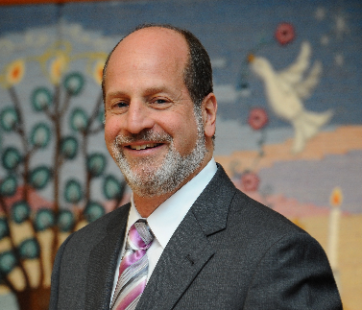

**报告人：**

**Prof. Marc M. Greenberg**

Department of Chemistry

Johns Hopkins University

**时间：**2018年7月25日（周三）16:00

**地点：**石先楼二楼学术报告厅

**About Prof. Greenberg:**

Prof. Greenberg obtained his BS and BE at New York University in 1982, and Ph D. at Yale University (Advisor: Jerome A. Berson). Later, he finished his postdoc research at California Institute of Technology (Advisor: Peter Dervan). He started his independent research in Colorado State University in 1990, and moved to the Johns Hopkins University in 2002. Currently he is Vernon K. Krieble professor in Department of Chemistry, and hold secondary appointments in Department of Biology and Oncology, Johns Hopkins University School of Medicine. He has published more than 200 papers*,* and has been awarded many honors, including American Association for the Advancement of Science Fellow (2010) and Arthur C. Cope Scholar (2016). His research has focused on Chemical and biochemical approaches to the study of DNA damage and repair, and their applications including the design of repair enzyme inhibitors, radiosensitizing agents, sensors for DNA lesions.