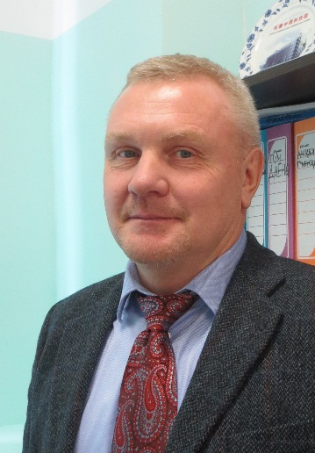**Alexander A. Trifonov**

**Director of**

**A.N. Nesmeyanov Institute of**

**Organoelement Compounds**

**of Russian Academy of Sciences**

28 Vavilova str., Moscow,

Russia, 119991

Tel: +7-499-135 61 66

Fax: +7-499-135 50 85

E-mail: [trif@iomc.ras.ru](mailto:trif@iomc.ras.ru)

http://www.ineos.ac.ru

Alexander A. Trifonov was born in 1962, studied chemistry at the State University of Gorky (USSR) and in 1984 received his diploma degree. During his PhD studies he has been working at the Institute of Organometallic Chemistry of Russian Academy of Sciences (Nizhny Novgorod) under supervision of Prof. M.N. Bochkarev and in 1989 received his PhD at the Institute of Organoelement Compounds of Russian Academy of Sciences (Moscow). He did postdoctoral studies at the Technical University of Berlin, Germany (Prof. H. Schumann, 1991), Université de Paris-Sud, France (Prof. H. Kagan, 1993-1995). In 1999-2000 he was an A. von Humboldt fellow in the research group of Prof. J. Okuda (Mainz University, Germany). After returning to the Institute of Organometallic Chemistry he defended the second thesis in 2003 and in 2005 became a head of the Laboratory of coordination chemistry. The appointment as professor at the Nizhny Novgorod State University (Russia) followed in 2005. Since 2016 he was a vice-director of Institute of Organoelement Compounds of Russian Academy of Sciences (Moscow) and in July 2018 was appointed a director of this institute.

His research interests lie in the area of synthesis of organometallic and coordination compounds of rare earth and alkaline earth metals and their application in homogeneous catalysis and material chemistry. He has published over 200 original papers and 11 reviews. He was an invited processor of Universities of Montpellier (France), Paris-Sud (France), Rennes (France), Bayreuth (FRG), Osaka (Japan), Institute of Organic Chemistry of Chinese Academy of Sciences (Shanghai, China), Institute of Applied Chemistry of Chinese Academy of Sciences (Changchun, China), Institute of Organometallic compounds (Florence, Italy). He is an advisory board member of Organometallics since 2014 and an International advisory board member of International Conferences on Organometallic Chemistry since 2006.